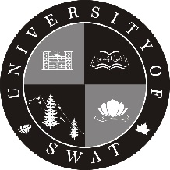
University of Swat
Centre for Plant Sciences and Biodiversity
Program Name: (e.g) BS Botany
Examination
Fall
Spring
Year
Session

2017
2017-21
Award List (for Courses without Lab. Work)
Fresh Repeat SCE Makeup IOG

Semester: I II III IV V VI VII VIII IX X

Course Title: (e.g) English-I
Teacher Name: ______________________________________ Credit Hours: (e.g) 03 (3-0)

Roll No. | Name of Student | Marks Obtained
 |  | MT (30) | FT (50) | Assig. (05) | Pres. (10) | Quizzes(05) | Total 100
*MT: Mid Term, FT: Final Term, Assig: Assignments, Pres: Presentations

Name of Examiner/Prof: ______________
Signature with date: __________________ Countersigned by HoD ____________

